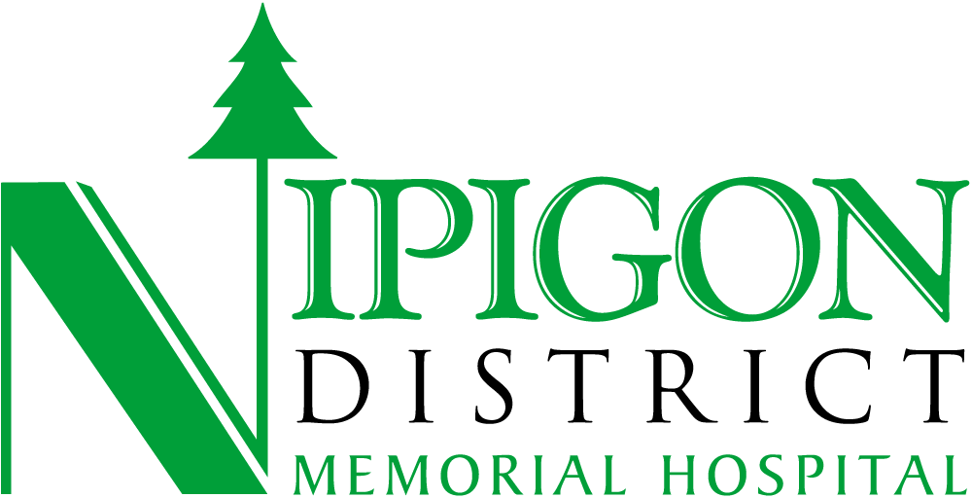

|  |  |  |
| --- | --- | --- |
| Nipigon District Memorial Hospital values your feedback. We are here for you. Your experience will help us further improve the quality of the care that we provide to our patients, and their families.  We are prepared and committed to responding to a request for accommodation for the accessible information and/or communication support, from people with disabilities.  Whether you have a compliment, complaint or comment, your feedback is important to us and we will acknowledge your concern within three (3) business days with the email or mailing address you provide.  Kyle Lemieux, Patient Relations Officer  [klemieux@ndmh.ca](mailto:klemieux@ndmh.ca)  (807) 887-3026 ext 1224 | | |
|  |  | |
| **The Hospital’s feedback process is, upon request, accessible to persons with disabilities by providing or arranging for the provision of, accessible formats and communication supports in a timely manner that considers the person’s accessibility needs due to disability.** | | |
| **YOUR** **FIRST/LAST NAME:** __________________________________________ | | |
| **I am a:**  🞎 Patient  🞎 Family member of a patient  🞎 Legal Decision Maker | | 🞎 Friend of a patient  🞎 Visitor / member of the public |
| **PATIENT’S FIRST/LAST NAME:** _______________________________________  (if not same as above)  **DATE OF SUBMISSION**: _____________________________________________ | | |
| **YOUR CONTACT INFORMATION**  Cell Phone ____________________ Home Phone ____________________  Email or Mailing Address: ________________________________________________ | | |
|  | | |
| **PLEASE SELECT THE TYPE OF FEEDBACK YOU ARE PROVIDING**  🞎 Compliment for staff, physicians, volunteers 🞎 Complaint about care  🞎 Suggestion to improve health care delivery / health service delivery | | |
| **WOULD YOU LIKE US TO CONTACT YOU? 🞎** Yes **🞎** No | | |
| **PLEASE USE THE OTHER SIDE TO TELL US YOUR STORY** | | |
| **TELL US YOUR STORY**  Date of Occurrence: __________________________________ | | |

Thank you for providing feedback. Your feedback on your experience with Nipigon District Memorial Hospital is important to assist us in improving our care and providing the highest quality care. Please note that if you are providing feedback for a loved one or someone other than yourself, we are committed to protecting the privacy of our patients and must fully comply with Personal Health Information protection legislation. We must have consent of the patient prior to disclosing any information on care to a third party.