

125 Hogan Road Nipigon, ON P0T 2J0

(807) 887-3026

**Multi Year**

**Accessibility Plan**

**2024 / 2028**

*This accessibility plan outlines the strategy of Nipigon District Memorial Hospital to prevent and remove barriers for people with disabilities and comply with the requirements of the Integrated Accessibility Standards Regulation under the Accessibility for Ontarians with Disabilities Act, 2005.*

*This plan is in effect from Apr 1, 2024 to Mar 31, 2028*

**Index**

|  |  |
| --- | --- |
| Section 1: Overview | |
| Accessibility for Ontarians with Disabilities Act (AODA) ………………………………….. | 3 |
| Four Core Principles of the AODA ………………………………………………………….. | 4 |
| Nipigon District Memorial Hospital’s Commitment ………………………………………… | 5 |
| Integrated Accessibility Standards, Ont. Reg. 191/11 ……………………………………. | 6 |
| Section 2: Past Achievements to Remove and Prevent Barriers | |
| Accessibility Plan Progress Report, March 2024 ………………………………………….. | 7 |
| Section 3: Goals and Objectives | |
| Goal 1 - Policies / Procedures / Practices …………………………………………………. | 8 |
| Goal 2 - Education and Training ……………………………………………………………. | 8 |
| Goal 3 - Assistive Devices …………………………………………………………………… | 10 |
| Goal 4 - Communicating to the Public ……………………………………………………… | 10 |
| Goal 5 - Feedback Processes ………………………………………………………………. | 10 |
| Goal 6 - Notice of Temporary Disruption …………………………………………………… | 11 |
| Goal 7 - Emergency Response ……………………………………………………………… | 11 |
| Goal 8 - Employment / Employees …………………………………………………………. | 11 |
| Goal 9 - Procuring Goods, Services and Facilities ……………………………………….. | 12 |
| Goal 10 - Design of Public Spaces …………………………………………………………. | 12 |
| Goal 11 - AODA Healthcare Standards ……………………………………………………. | 12 |

|  |
| --- |
| Section 1: Overview |

Accessibility for Ontarians with Disabilities Act, (AODA)

The Accessibility for Ontarians with Disabilities Act, or AODA, aims to identify, remove and prevent barriers for people with disabilities. The AODA became law on June 13, 2005 and applies to all levels of government, non profits, and private sec tor businesses in Ontario that have one or more employees (full time, part time, seasonal, or contract).

The AODA includes requirements that all organizations must meet, with deadlines specific to an organization’s type and size. The AODA gives government authority to set monetary penalties to enforce compliance with accessibility standards. The maximum penalties under the AODA include:

* A corporation/organization that is guilty can be fined up to $100,000 per day
* Directors and officers of a corporation/organization that is guilty can be fined up to $50,000 per day

The AODA complements, but does not supersede, the requirements of accessibility and accommodation described under the Ontario Human Rights Code.

Four Core Principles of the AODA

Dignity

Policies, procedures and practices that respect the dignity of a person with a disability are those that treat them as customers and clients who are as valued and as deserving of effective and full service as any other customer. They do not treat people with disabilities as an afterthought or force them to accept lesser service, quality or convenience.

Service delivery needs to take into account how people with disabilities can effectively access and use services and show respect for these methods.

### Independence

In some instances, independence

means freedom from control or influence of others - freedom to make your own choices.

In other situations, it may mean the freedom to do things in your own way. People who may move or speak more slowly should not be denied an opportunity to participate in a program or service because of this factor. A staff person should not hurry them or take over a task for them if they prefer to do it themselves in their own way.

### Integration

Integrated services are those that allow people with disabilities to fully benefit from the same

services, in the same place and in the same or similar way as other customers.

Integration means that policies, practices and procedures are designed to be accessible to everyone including people with disabilities.

Sometimes integration does not serve the needs of all people with disabilities. Alternative measures, rather than integration, might be necessary because the person with a disability requires it or because you cannot provide another option at the time. If you are unable to remove a barrier to accessibility, you need to

consider what else can be done to provide services to people with disabilities.

### Equal Opportunity

Equal opportunity means having the same chances, options, benefits and results as others.

In the case of services, it means that people with disabilities have the same opportunity to benefit from the way you provide goods or services as others. They should not have to make significantly more effort to access or obtain service. They should also not have to accept lesser quality or more inconvenience.



Nipigon District Memorial Hospital’s Commitment

#### Nipigon District Memorial Hospital is committed to -

#### ensuring equal access for people with disabilities and treating people with disabilities in a way that allows them to maintain their dignity and independence and includes the principles of integration and equal opportunity

#### be a barrier-free environment for persons with disabilities in employment, in its communications and information, in the delivery of goods and services and in its built environment

#### We will do so by removing and preventing barriers to accessibility and meeting our accessibility requirements under the AODA and Ont Reg 191/11 Integrated Accessibility Standards in a timely manner and as much as reasonably possible.  The Hospital is committed to ensuring that all its employees are aware of their responsibilities to foster an accessible and inclusive environment with, and for, persons with disabilities.

Shannon Cormier

Chief Executive Officer

Integrated Accessibility Standards, Ont. Reg. 191/11

The Integrated Accessibility Standards Regulation (IASR) toprevent and remove barriers for people with disabilities.

In April 2024, the standards that relevant to Nipigon Hospital included:

* Information and Communication
* Employment
* Customer Service
* Design of Public Spaces

Nipigon Hospital has maintained its compliance with accessible parking and signage in public and staff parking facilities for many years.

In May 2024, the resident court yard was dismantled and redesigned requiring the referencing of the standard for the Design of Public Spaces and the development of a Hospital policy/procedure.

Additionally, Nipigon Hospital is currently in the early phase of making application for an expansion to our Long Term Care home. Should this application come to fruition, the requirements of the Design of Public Spaces standard will be applied.

|  |
| --- |
| Section 2: Past Achievements to Remove and Prevent Barriers |

Nipigon District Memorial Hospitals road to removing and preventing barriers under the Accessibility for Ontarians with Disabilities Act and its regulations has been an ongoing process since 2010.

Our journey is documented through our Accessibility Plans and Progress reports, the most Plan ending in March 2024.

To review our past achievements, please go to our website to access our Accessibility Progress Report of March 2024.

Nipigon Hospital is committed to provide:

* an accessible environment for all clients, employees, job applicants, suppliers and visitors who may enter our premises, access our information, or use our services, and
* our dedication to promoting diversity, equity, inclusion, and belonging in the workplace

the following pages, are the strategies and actions identified as opportunities for growth and improvement in our ongoing efforts to remove and prevent barriers at Nipigon Hospital.

Section 3: Goals and Objectives

Nipigon Hospital is committed to providing accessible customer service to people with disabilities. This means that anyone who, on behalf of Nipigon Hospital, is providing access to the goods, services and facilities to people with disabilities with the same high quality and timeliness as others.

To ensure our continued compliance the following initiatives will be initiated, and if already in place, improved upon.

**Goal 1**

**Policies / Procedures / Practices**

Objective 1 - Review, and revise as required, all accessibility policies, procedures, practices as they pertain to Nipigon Hospital.

|  |
| --- |
| * Statement of Commitment * Procuring Goods, Services and Facilities |
| * Information and Communication |
| * Employment |
| * Employee Individual Accommodation Plan |
| * Employee Emergency Response Plan |
| * Customer Service |
| * Service Animals |
|  |

**Goal 2**

**Education and Training**

Objective 1 - Consider a new AODA free online education ([www.aoda.ca](http://www.aoda.ca)) which is far more comprehensive and relevant to all staff and includes quizzes, a final test and a certificate upon successful completion.

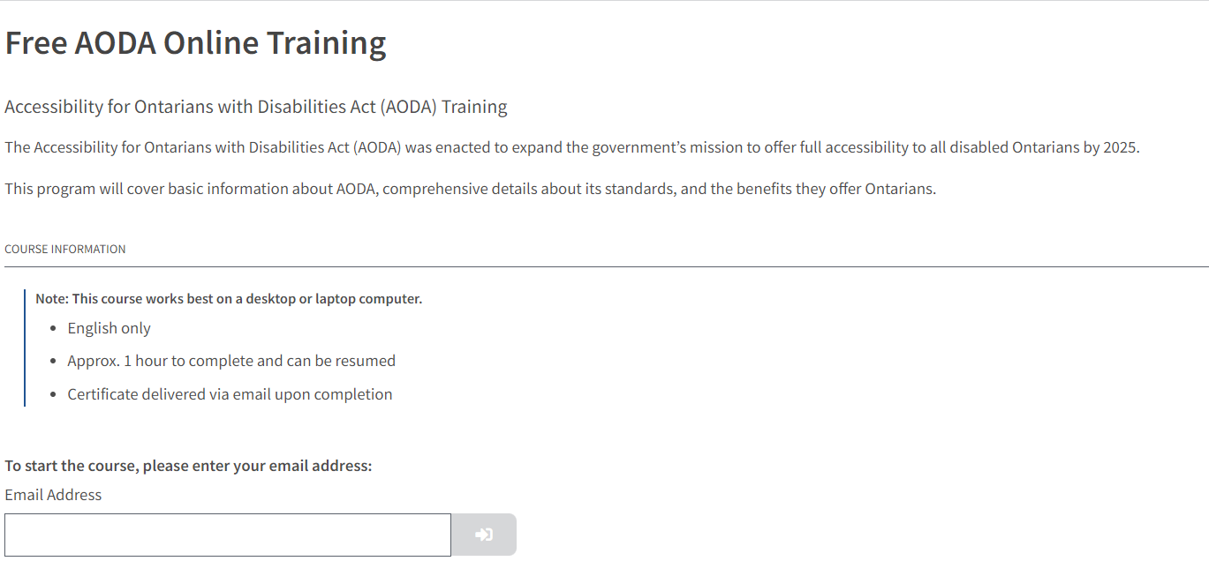

Objective 2 - Change current accessibility education via Surge Learning Management System (CNIB Clear Print Guide, Electronic Desk Magnifier, Pocker Talker Amplifier, from all staff to department specific.

Objective 3 - Create content for mandatory, face to face, Lunch and Learn to identify key learning of accessible goods, services and facilities provided by Nipigon Hospital. All employees required to attend.

* service animals
* support persons
* assistive devices
* accessible devices
* alternative formats
* feedback processes
* temporary disruptions
* employee individual accommodations plan
* employee emergency response plan
* procuring goods, services and facilities

Objective 4 - Under the current Surge Learning Management System, the AODA education identified above is only issued to staff on orientation. Identify a regular review timeline for all staff.

Objective 5 - Maintain training records that include date and names of employees who have successfully completed.

Objective 6 - Identify and provide education to select staff regarding individual accommodation plans / emergency response plans.

Objective 7 - Identify and provide education to staff regarding procuring goods, services and facilities.

Objective 8 - Identify and provide education to select staff regarding the design of public spaces

**Goal 3**

**Assistive Devices**

Objective 1 - Provide access to wheel chairs at the main entrance of the facility.

Objective 2 - Revisit purchase of porter chairs

Objective 3 - Consider purchasing several ergonomic soft shoulder rests for telephones.

**Goal 4**

**Communicating to the Public**

Objective 1 -Determine our effectiveness at informing the public about the availability of accessible formats and communication supports upon request, via our website

Objective 2 - Develop a plan to move towards compliance with the Hospital’s internet, website and web content, and intranet with the WCAG 2.0 standards at level AA in accordance with the schedule set out in Ont. Reg 191/11 as required as of January 1, 2020.

Objective 3 - Ensure icons on intranet / website for increase or decrease font size

(see Goal 7 - Objective 1, as it pertains to public safety information)

**Goal 5**

**Feedback Processes**

Objective 1 - Update the following policies/procedures to include a statement indicating the option to provide feedback and obtain a response to that feedback through an alternate method and/or with communication supports, upon request.

* Patient Relations Process
* LTC Complaints Process

**Goal 6**

**Notice of Temporary Disruption**

Objective 1 - Identify which services may have temporary disruption (ie. meals on wheels, servicing of equipment, change in department hours)

Objective 2 - Determine how best to provide this information to customers. (ie. direct contact vs social media, signage)

**Goal 7**

**Emergency Response**

Objective 1 -Include the requirements of the AODA as it pertains to emergency procedure, plans or public safety information in the review, revision and development of the Hospital’s Emergency Management Plans

Objective 2 - Develop a template for employee emergency response plan

(see Goal 8 - Employment / Employees for more objectives on employee emergency response plan)

**Goal 8**

**Employment / Employees**

Objective 1 - Develop the following templates with consistent accessibility accommodation messaging.

* Job posting
* Letter of offer
* Performance management tool

Objective 2 - Develop a template for employee individual accommodation plan

Objective 3 - Together with OHN, offer existing employees with reported disability the opportunity for an individual accommodation plan / emergency response plan.

Objective 4 - Together with OHN, offer new employees with reported disability the opportunity for an individual accommodation plan / emergency response plan.

Objective 5 - OHN to develop and maintain a record of individual accommodation plans provided under the requirements of the AODA

Objective 6 - OHN to develop and maintain a record of emergency response plans provided under the requirements of the AODA

Objective 7 - Include disabled employees with or without individual accommodation plan / emergency response plan to participate in an advisory capacity.

**Goal 9**

**Procuring Goods, Services and Facilities**

Objective 1 - Review, and revise as required current Procuring Goods, Services and Facilities document.

Objective 2 - When meetings take place around the procuring of goods, services and/or facilities, and where meeting minutes are recorded, document occasions where IASR’s Procuring Goods, Services and Facilities document was referenced and utilized.

**Goal 10**

**Design of Public Spaces**

Objective 1 - Provide education to select staff regarding the design of public spaces

Objective 2 - Develop policy/procedure as it pertains to Nipigon Hospital, including accessible parking

Objective 3 - When meetings take place around the design of public spaces (court yard renovation / LTC expansion) and where meeting minutes are recorded, document occasions where IASR’s Design of Public Spaces was referenced and utilized.

Objective 4 - Accessible parking has not previously been identified or reported. Ensure the reporting of compliance with accessible parking and signage in public and staff parking facilities.

**Goal 11**

**AODA Healthcare Standards**

Objective 1 - In preparation for legislated addition to the current AODA standards, provide education to select staff regarding the Ontario government’s work on the development of healthcare standards by reviewing documents “*Development of* *Health Care Standards - Final Recommendations Report 2022*”, and “*Health Care Standards Easy Read”.*